Illinois State University School of Information Technology
IT 276

Lab 12
DNS /UDP /IPv4 – Packet Format

Please insert Wireshark screen captures to support your answers.

Recall that a typical 20-byte IPv4 header looks like this:

Version | HLEN |  | Service Type | Total Length
Identification |  |  |  | Flags | Fragment Offset
TTL |  | Protocol |  | Header Checksum
Source IP address
Destination IP address

In this lab, we will repeat the same steps as in Lab 8 but for a DNS trace. Start a new Wireshark capture. On your Command Prompt, type:

nslookup www.fifa.com

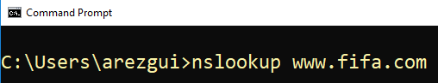

To show only the DNS packets related to our nslookup command:

On Wireshark, put the following text in the filter bar: dns.qry.name==www.fifa.com

You should see a Wireshark screen similar to this one:

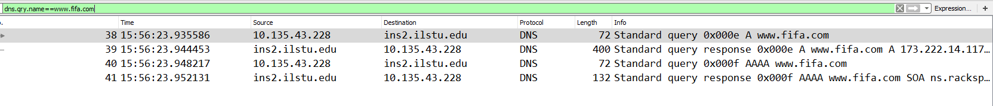

- For the two first IP two packets, fill out the fields of their IPv4 headers:

Packet 1 (DNS query)

4 | 20 |  | Service Type | 58
Identification |  |  |  | Flags | Fragment Offset
 |  | UDP (17)
10.135.23.56
138.87.128.1

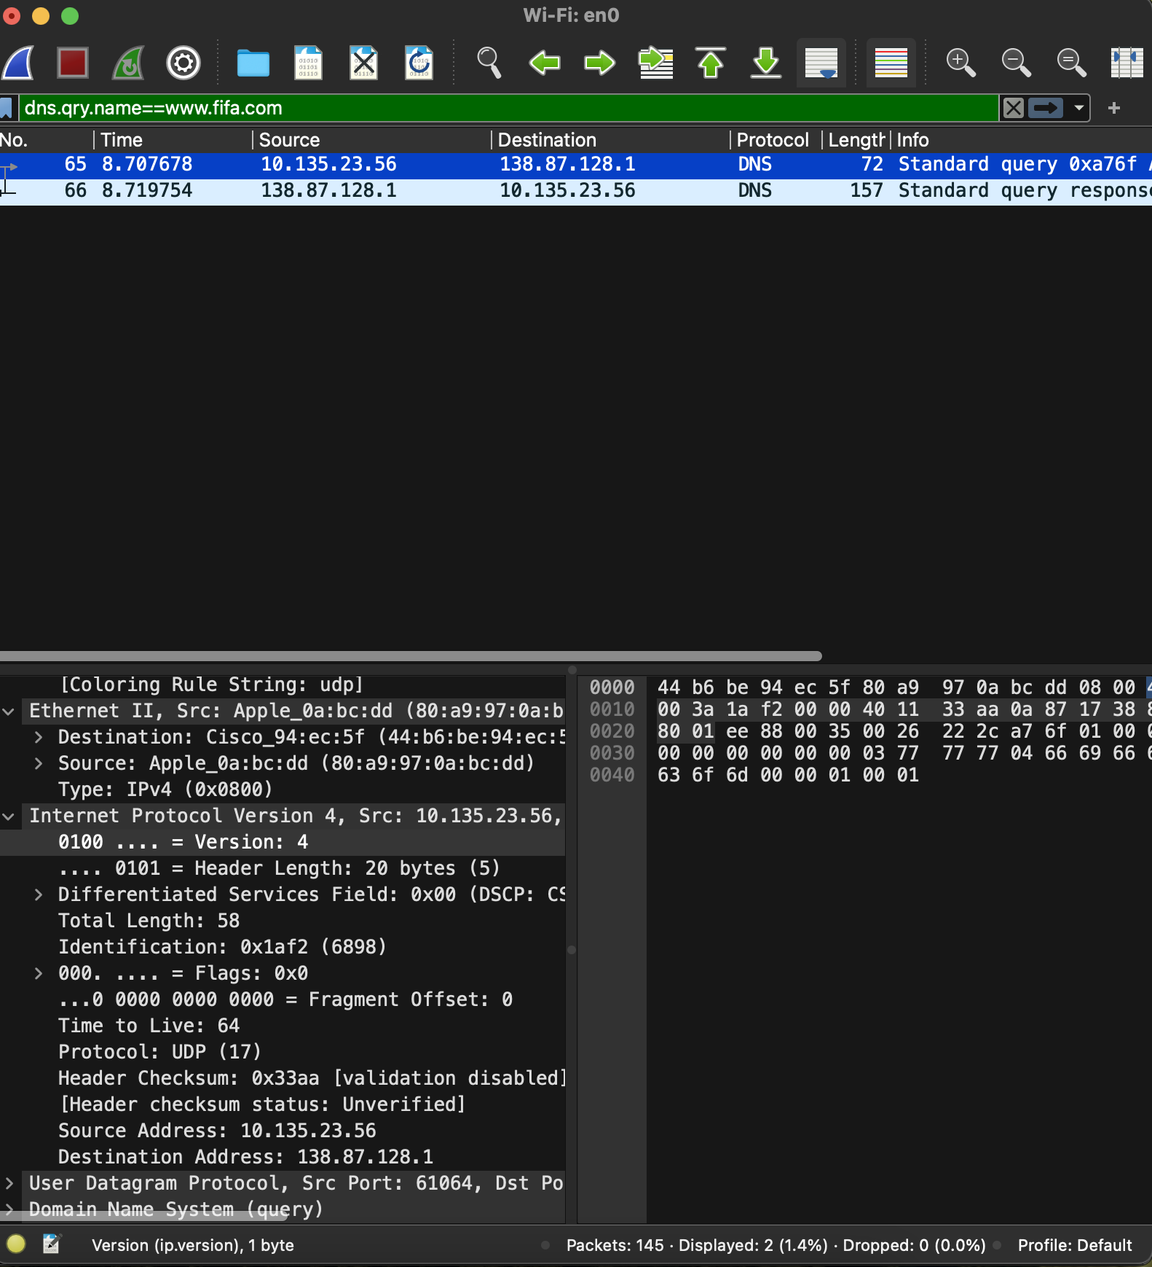
Packet 2 (DNS response)

4 | 20 | Service Type |  | 143
Identification |  |  | Flags |  | Fragment Offset
 | UDP (17)
138.87.128.1
10.145.23.56
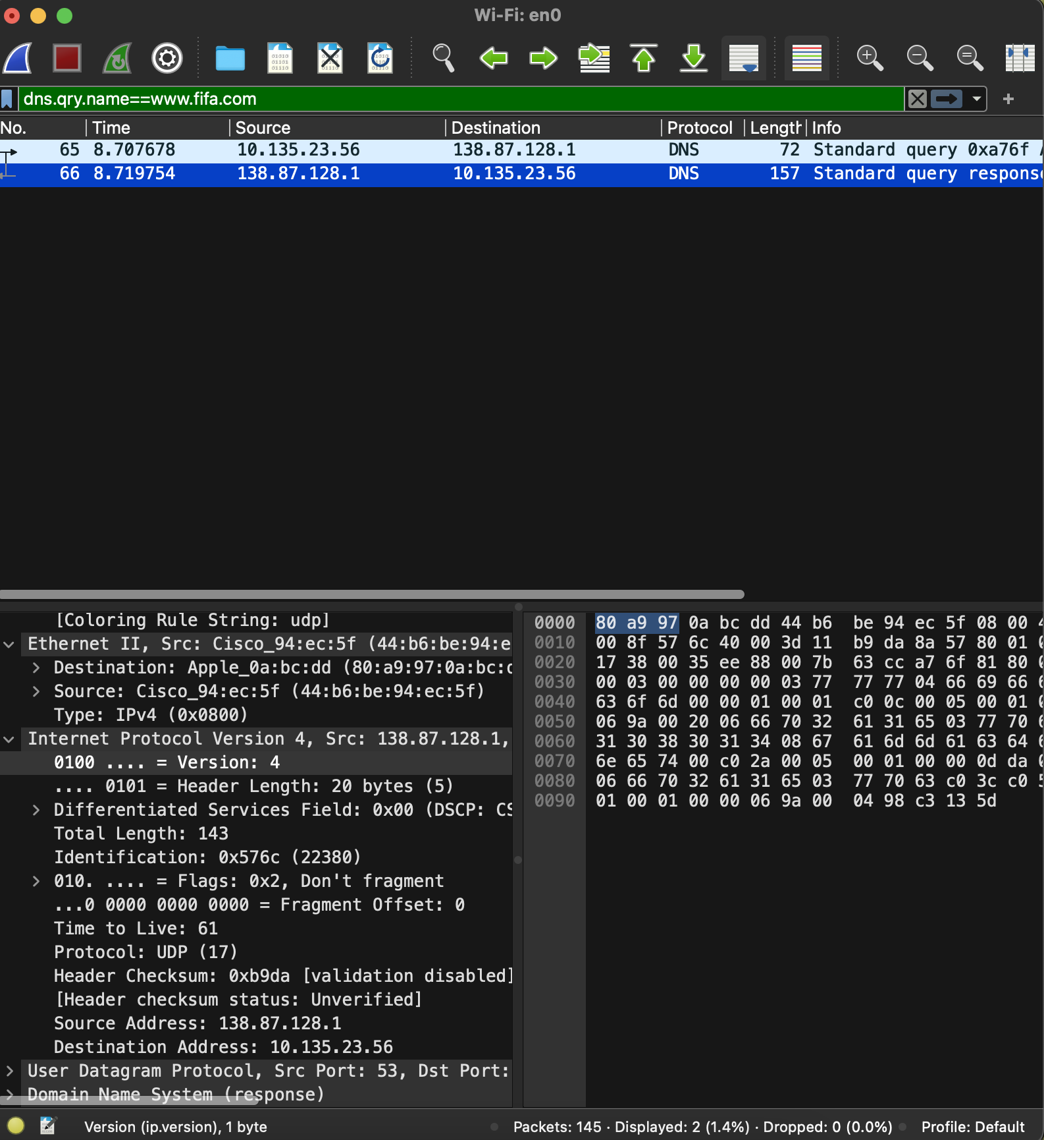
- What is the type of segment inside the first two IP packets: a TCP segment or a UDP segment?
UDP Segment

- How do you know? Because the value of the field Protocol is ……….
17

- For the two first packets, fill out the following table:

 | # of bytes in the UDP header | # of bytes in the IP header | Total size of IP packet | Size of the DNS message
Packet 1 (DNS request) | 20 | 20 | 58 | 18
Packet 2 (DNS response) | 20 | 20 | 143 | 103

